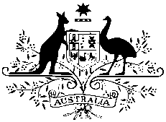

Australian High Commission

MEDIA RELEASE
29 August 2017

More Australian students than ever before to visit Sri Lanka under the New Colombo Plan

More Australian students than ever before will head to Sri Lanka in 2018 under the Australian Government’s New Colombo Plan mobility program.

“226 students will take part in 15 projects in Sri Lanka next year, covering areas from the environment to business studies to medicine,” Australia’s High Commissioner Bryce Hutchesson said. “We will also see 28 students participate in New Colombo Plan projects in Maldives next year as the New Colombo Plan goes from strength-to-strength across the region”.

“We look forward to welcoming students from fourteen Australian universities to learn more about the people and the culture of Sri Lanka and Maldives. Students will return to Australia with new friendships and connections that will last a lifetime, as well as new perspectives on Sri Lanka and Maldives that will contribute to the relationships between our countries for decades to come,” High Commissioner Hutchesson said.

In 2018, more than 13,000 Australian students will take part in New Colombo Plan mobility projects in 35 locations across the Indo-Pacific.

The New Colombo Plan is helping the next generation of Australian leaders learn more about the region by supporting students to study and undertake work placements in the Indo-Pacific.

