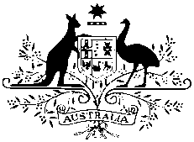

**Australian High Commission**

**MEDIA RELEASE**

**8 March 2018**

**Australian Direct Aid Program Call for Applications**

The Australian High Commission’s Direct Aid Program (DAP) is now open for applications. The DAP has helped hundreds of organisations around the world, including in Sri Lanka and Maldives, to make a real difference to their communities.

The DAP is a flexible small grants program that provides financial support for development projects in areas such as poverty alleviation, health, education, rural development and gender equality.

Australian High Commissioner Bryce Hutchesson said ‘The Direct Aid Program supports grassroots development activities in Sri Lanka and around the world. If your organisation has a great idea to help your community, we would love to hear from you.’

DAP funding is available to legally registered community groups and NGOs, academic institutions and local government institutions engaged in development activities on a not-for-profit basis. Applications are generally for one year and valued up to LKR 3 million.

The DAP is open for applications until **06 April 2018**. All applications should be submitted online via the Smartygrants portal on the High Commission’s website <http://srilanka.embassy.gov.au/clmb/DAPSriLanka.html>

Enquiries should be addressed to the DAP Coordinators at [DAPColombo@dfat.gov.au](mailto:DAPColombo@dfat.gov.au)