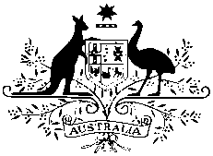

Australian High Commission

MEDIA RELEASE

23 August 2017

Australian Direct Aid Program Call for Applications

The Australian High Commission’s Direct Aid Program (DAP) is now open for applications. The DAP has helped hundreds of organisations around the world, including in Sri Lanka and Maldives, to make a real difference to their communities.

The DAP is a flexible small grants program that provides financial support for development projects in areas such as poverty alleviation, health, education, rural development and gender equality. Part of the $29 million Australian development assistance to Sri Lanka, in 2016-17 the DAP supported 14 Sri Lankan organisations to help their communities, from establishing libraries to providing psychosocial support and educational opportunities for people with disabilities.

Australian High Commissioner Bryce Hutchesson said ‘The Direct Aid Program has helped communities across Sri Lanka over many years, and I’m pleased to able to launch the new round of DAP applications for 2017-18. If your organisation has a great idea to help your community, we would love to hear from you.’

DAP funding is available to legally registered community groups and NGOs, academic institutions and local government institutions engaged in development activities on a not-for-profit basis. Applications are generally for one year and valued up to LKR 3 million.

The DAP is open for applications until 30 September 2017. All applications should be submitted online via the Smartygrants portal on the High Commission’s website http://srilanka.embassy.gov.au/clmb/DAPSriLanka.html

Enquiries should be addressed to the DAP Coordinators at DAPColombo@dfat.gov.au

